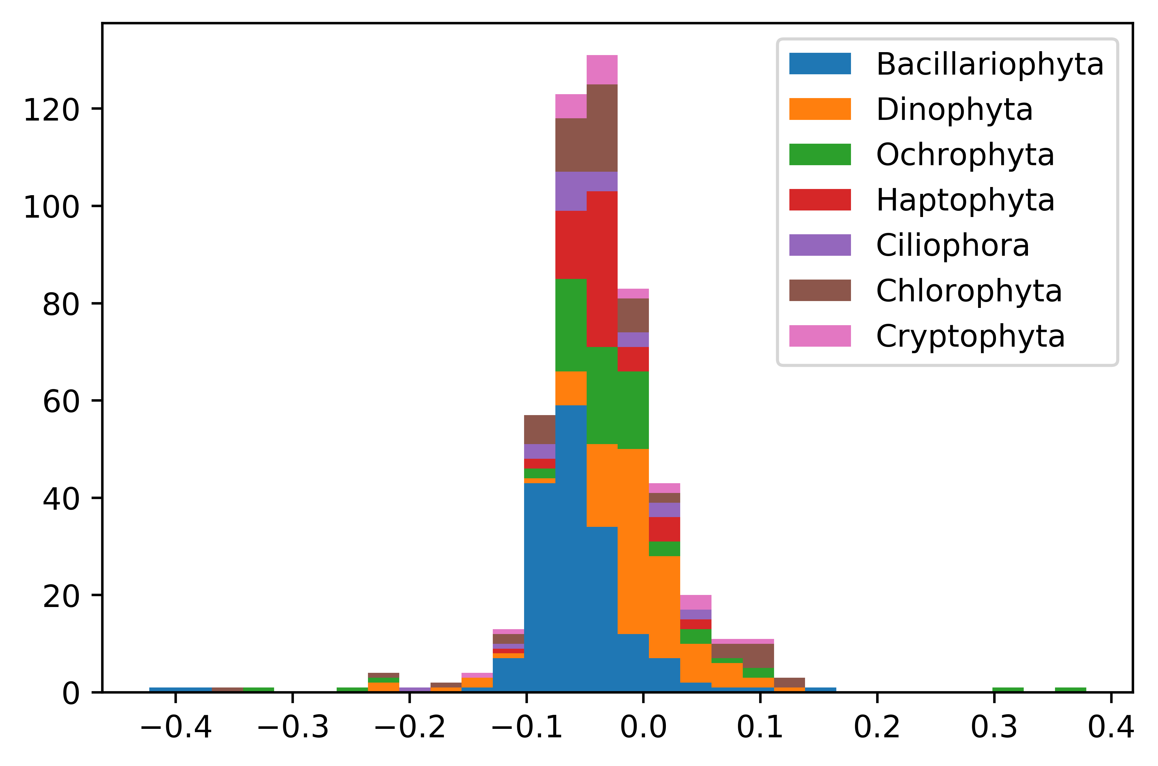

Supplemental Figure 2. Frequency distribution of differences between Transrate scores between the NCGR ‘nt’ assemblies and the DIB re-assemblies grouped by the top seven most represented phyla in the MMETSP data set. Negative values indicate that Transrate scores from NCGR ‘nt’ assemblies were higher than the score from the DIB re-assemblies and positive values indicate that scores from DIB re-assemblies were higher than the NCGR ‘nt’ assemblies.